Name: **ZOHAIB HASSAN SOOMRO**

RollNo#: **19SW42**

Subject: **DBS**



1. Create a table named Emp that will have 3 columns as:
2. Emp_ID with NUMBER data type. (Also PK)
3. Emp_Name with varchar data type and length 30.
4. emp_address with varchar data type and length 20.
5. Add check on EMP_ID so that Emp_Id is not null and unique

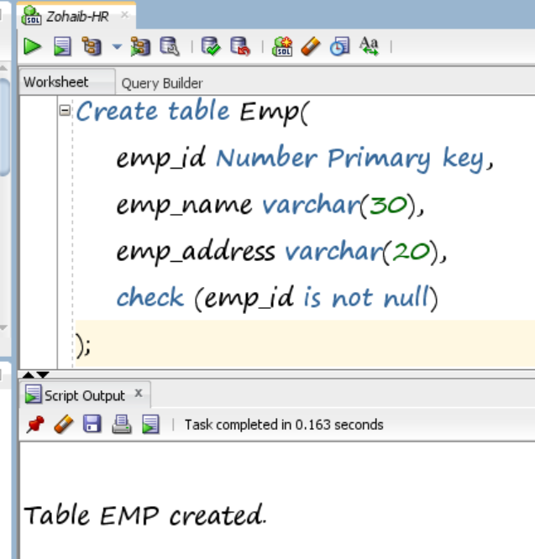

1. Write a query that returns all the employees, their related information and dept name and even those department where no employee is working.

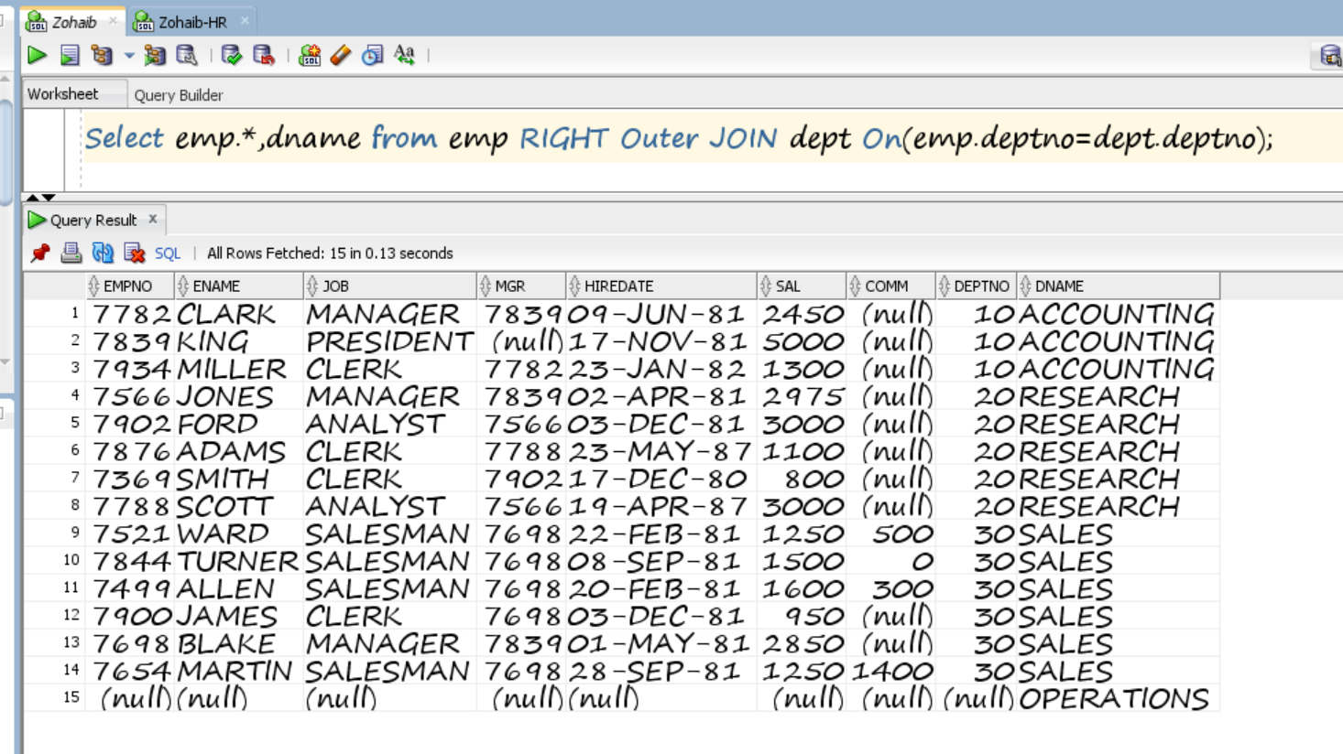

1. Write a query that displays employees whose job title is the same as that of employee 7569 and whose salary is greater than that of employee 7976.

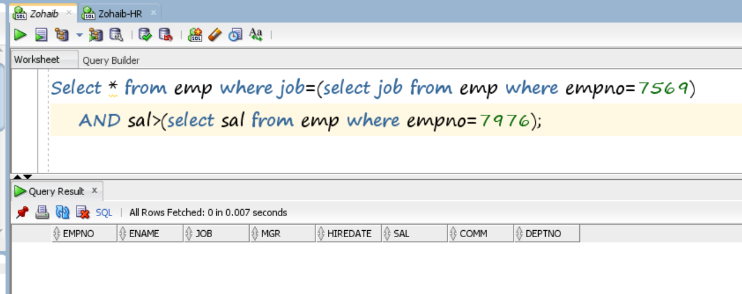

1. Write a SQL statement displays all the employees whose salary is less than 200 and who are not SALESMAN.

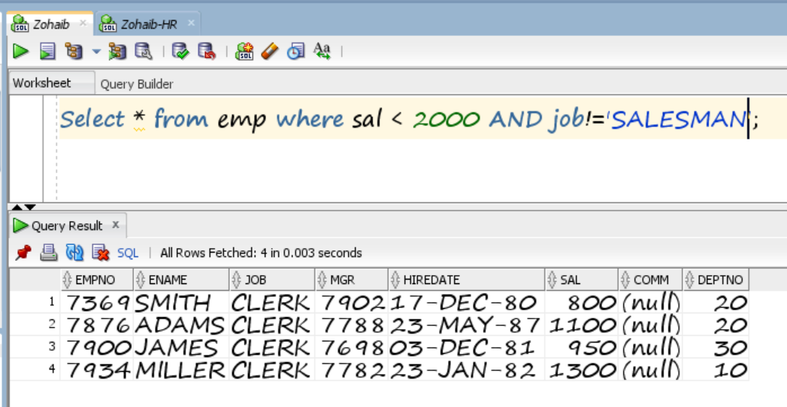

1. Create a view call employee_vu based on the employee numbers, employee names and department numbers from the emp table. Change the heading for the ename to EMPLOYEE.

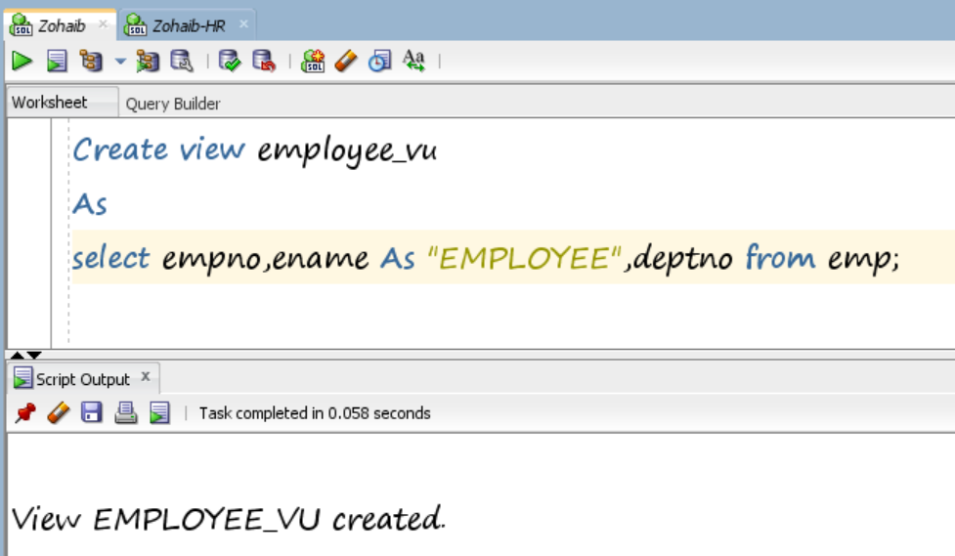

1. Convert following table into 1NF, 2NF, 3NF

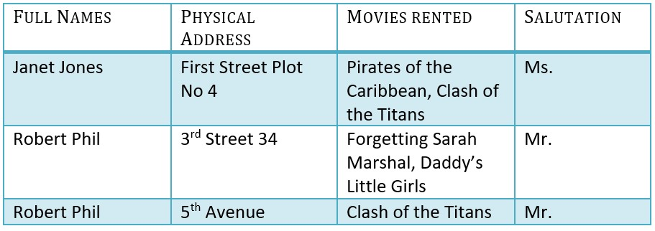

1. Convert following table into Demoralization

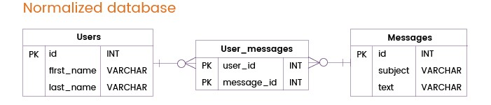

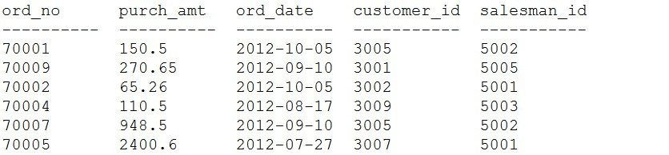

Figure 1

Ref Figure 1 and Perform following task

1. Make an Order Table based on the above given Structure.

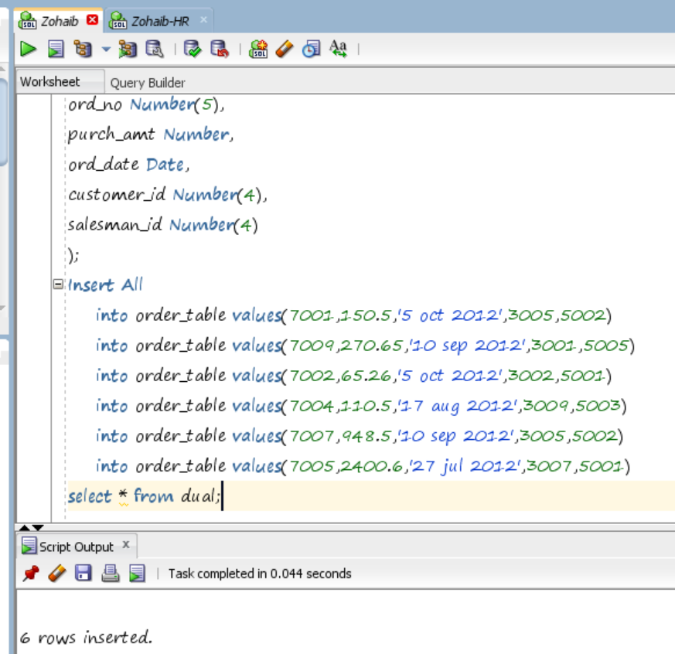

1. Select the orders with all information in such a manner that, the older order date will come first and the highest purchase amount of same day will come first.

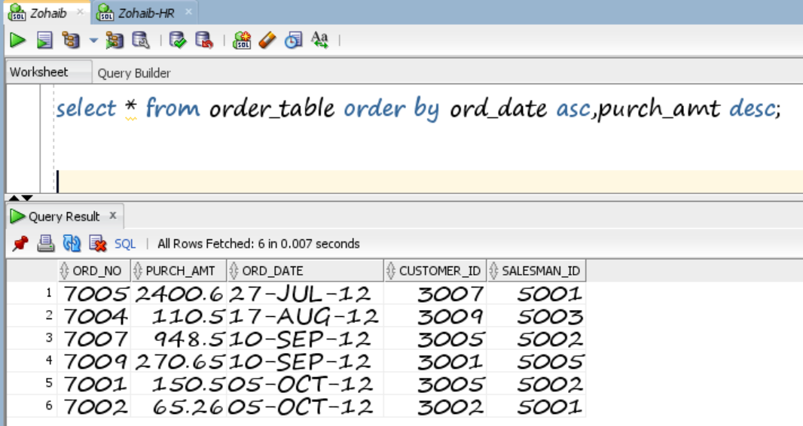

1. Select the order date in such a manner that, the latest order date will come first along with the total purchase amount and total commission (15% for all salesmen) for that date.

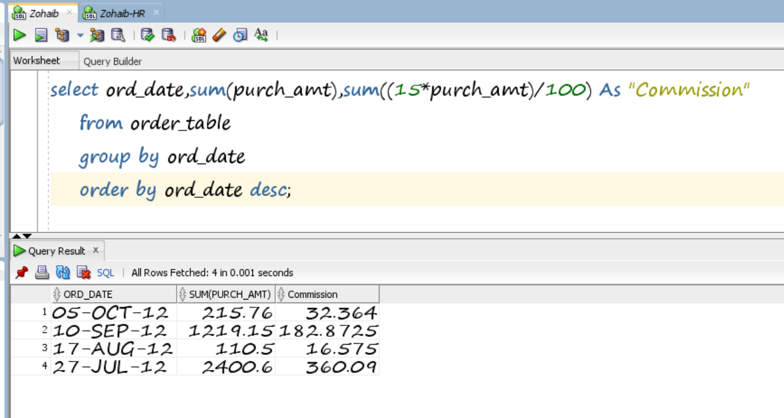

1. Identify all the orders issued against the salesman who works for customer whose id is 3007.

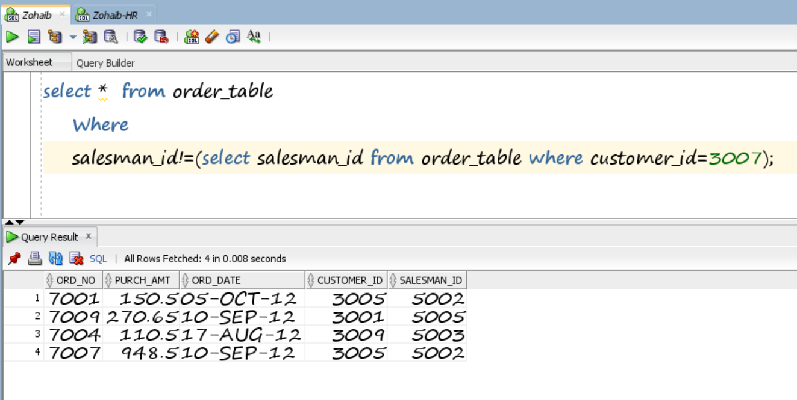

1. Identify all the orders which values are greater than the average order value for 10th October 2012.

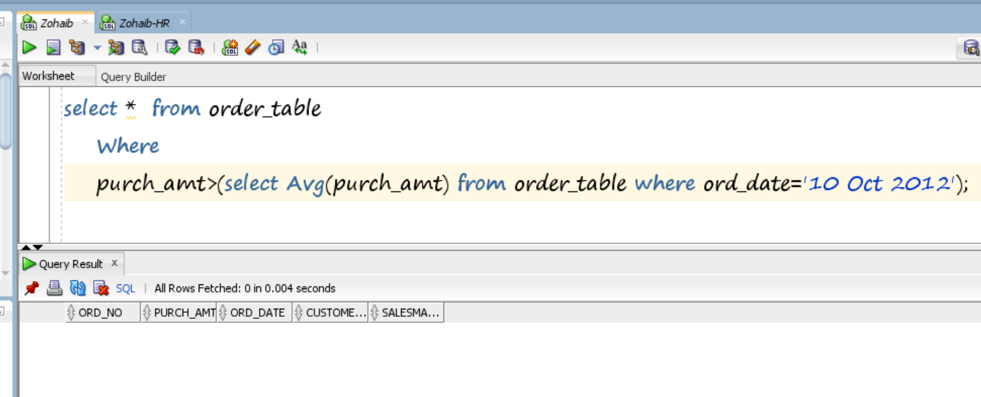

Consider the following table for queries. EMP (EMPNO, ENAME, JOB, MGR, HIREDATE, SAL, COMM, DEPTNO).

1. Illustrate detailed structure of the data retrieval command along with its various supporting clauses with suitable examples.

**Ans:**

An SQL SELECT statement retrieves records from a database table according to clauses (for example, FROM and WHERE) that specify criteria. The syntax is:

SELECT column1, column2 FROM table1, table2 WHERE column2='value';

In the above SQL statement:

* The SELECT clause specifies one or more columns to be retrieved; to specify multiple columns, use a comma and a space between column names. To retrieve all columns, use the wild card * (an asterisk).
* The FROM clause specifies one or more tables to be queried. Use a comma and space between table names when specifying multiple tables.
* The WHERE clause selects only the rows in which the specified column contains the specified value. The value is enclosed in single quotes (for example, WHERE last_name='Vader').
* The semicolon (;) is the statement terminator. Technically, if you're sending only one statement to the back end, you don't need the statement terminator; if you're sending more than one, you need it. It's best practice to include it.

1. Identify the total salary being paid to each job title within each department.

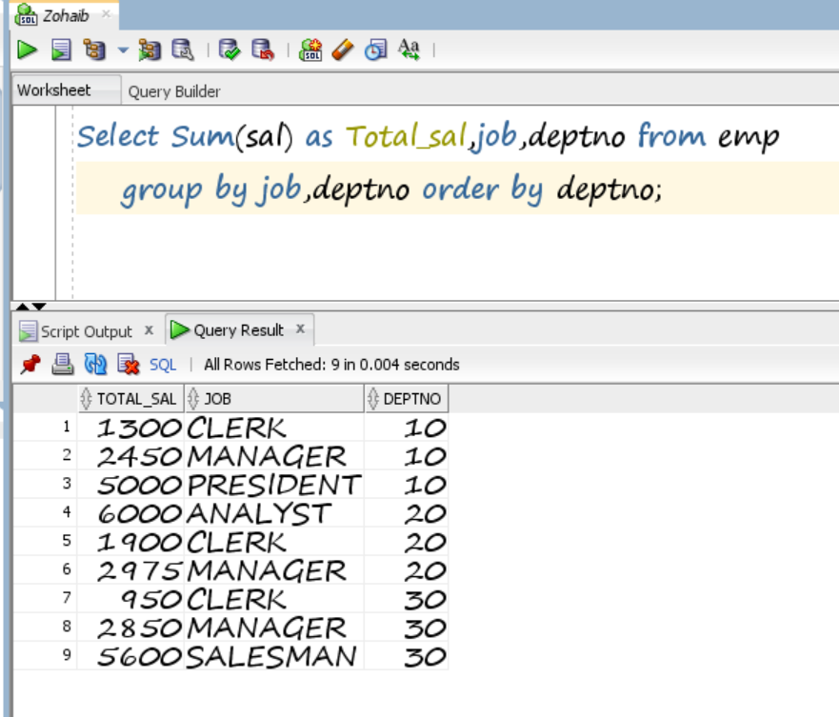

1. Create table students with columns std_id (primary key), std name (not null)
   1. Insert 5 different records in student table and show on console whether all records are successfully inserted or not.

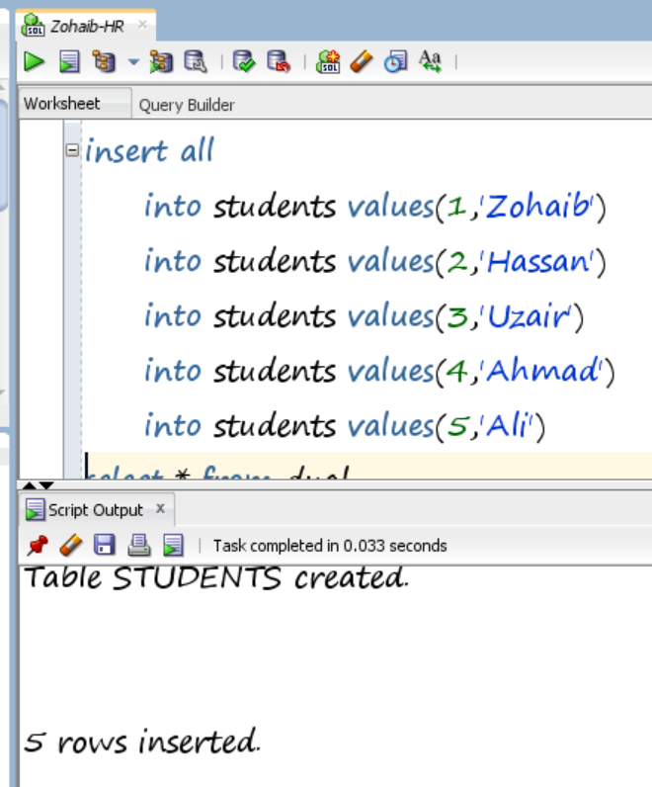

* 1. Select inserted records

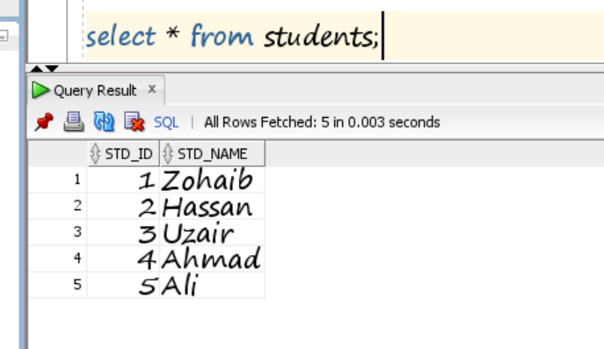

* 1. Update 2 selected records and display their success on console.

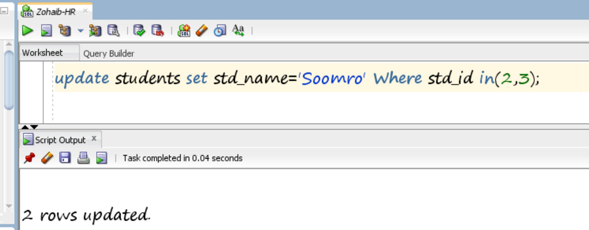

* 1. Select updated records

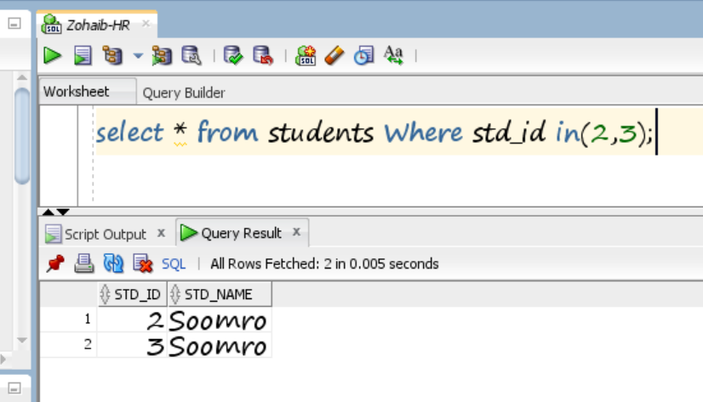

* 1. Delete one of the updated record and display its success on console.

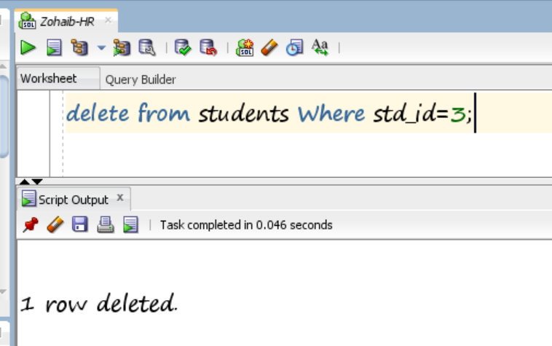

* 1. Select all the records and print them on console.

